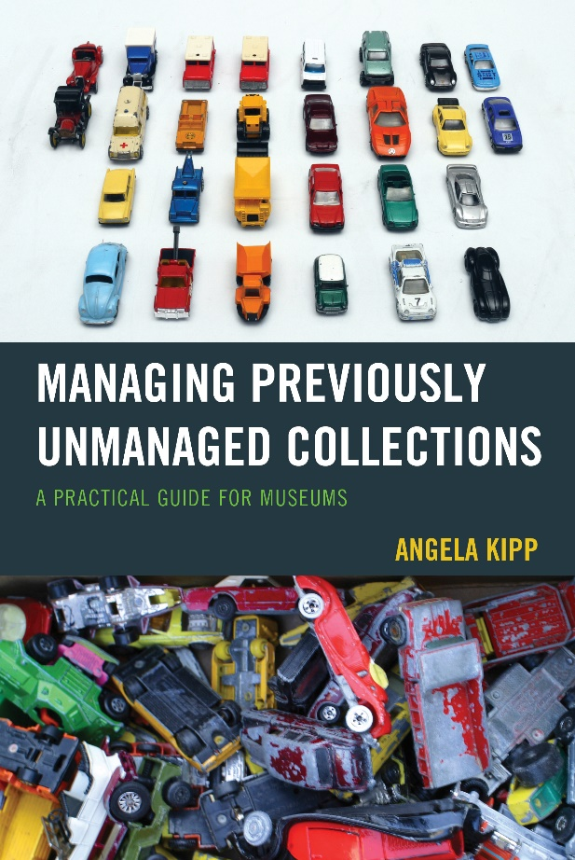 | Managing Previously Unmanaged Collections  A Practical Guide for Museums  By Angela Kipp  SPECIAL OFFER  30% DISCOUNT OFF LIST PRICE USING CODE RLFANDF30  Hardcover 978-1-4422-6347-5 • $75.00, after discount $52.50  Paperback 978-1-4422-6348-2 • $32.00, after discount $22.40  eBook, 978-1-4422-6349-9, list price • $31.99, after discount $22.40

About the Book

Managing previously unmanaged collections can be challenging. The process of securing the collection and making it accessible needs the mindset of a collections manager as well as the one of a project manager. The book is a step-by-step guide how to approach this situation, assuming that there's nothing to start with but a collection that has to be accessioned and the person who is assigned to do it. It is about how to bring order into the chaos, to define what is needed in terms of time, money, staff and material, to spot facility issues and potential dangers, and to use the power of networking to solve an otherwise unsolvable task.

About the Author
Angela Kipp is the Collections Manager of the TECHNOSEUM in Mannheim, Germany and an independent museum consultant with a special focus on science, technology, farming and history collections. She holds the German Museum Studies degree of Diplom-Museologin (FH) and has worked in the museum field since 1998. She worked for various institutions including large museums like the Museum für Kommunikation (museum for communication) in Berlin and the Deutsches Museum in Munich, as well as for many smaller museums and cultural projects. She specializes in logistics, project management and the adaption of technology for the special needs of museums.

Table of Contents

Chapter 1: Congratulations, It's Your Mess Now!
Chapter 2: A First Glimpse
Chapter 3: Back at the Desk
Chapter 4: Getting Organized
Chapter 5: Diving into the Collection
Chapter 6: The Power of Coffee
Chapter 7: Getting Stuff Done
Chapter 8: Storage Wants and Storage Needs
Chapter 9: We Had Nothing
Chapter 10: Failing Successfully
Chapter 11: Success Stories

Review

Managing Previously Unmanaged Collections is a must have for the library of any collections caretaker! This book takes the ideas of project management and applies them to those messy collections that we all face at least once in our career. Kipp provides guidelines that will help both the new collections manager and veterans work their way through those unmanaged collections.

- Deborah Rose Van Horn, Registrar, Kentucky Historical Society & Chair, Southeastern Registrars Association

ORDER FORM (billing in U.S. dollars) Please send me the following book right away:
ISBN | Title |  | Price |  |  | Qty. | Cost
978-1-4422-6347-5 | Managing Previously Unmanaged Collections (Cloth) |  | after discount:  $52.50
978-1-4422-6348-2 | Managing Previously Unmanaged Collections (Paperback) |  | after discount:  $22.40
 |  |  |  |  | Promo Code* |  | RLFANDF30
 |  |  |  | Shipping Costs
 | Applicable state sales tax will be applied at time of order
 |  |  |  |  |  | Total

- ebooks can be ordered online
- Promotional price on books is for U.S. orders only | offer expires Dec. 31, 2016 and may not be combined with other offers
• Shipping and handling: U.S.: $5 first book, $1 each additional book
      - Rowman & Littlefield Publishing Group offers special discounts for bulk purchases in the United States by corporations, institutions, and other organizations. For more information, please contact our Customer Service Department at special.sales@rowman.com or by phone at 800-462-6420 ext 3023.

WAYS TO ORDER: Go to rowman.com
Call toll-free: 1-800-462-6420 / fax this order form toll-free to: 1-800-338-4550
Or mail this order form to: Rowman & Littlefield, 15200 NBN Way, P.O. Box 191
Blue Ridge Summit, PA 17214-0191
All orders from individuals must be prepaid / Prices are subject to change without notice

Please check: Mastercard Visa Amex
Personal check (make payable to Rowman & Littlefield)

Credit Card #: Exp. Date
Signature:

BILLING AND SHIPPING ADDRESS:
Name
Institution
Street
City, State, Zip
Country
Phone

